**Assignment 2**

**Problem statement**

In this assignment, you will build all the main pages of the e-commerce website

using Bootstrap framework. Please make sure that you have completed the module

before you start with the assignment as this will help in your module test.

Here is the list of the pages you will create:

1. Index page

2. Login page

3. Signup page

4. Product page

5. Cart page

6. Settings page

7. Success page

This document explains how to build each of these pages using Bootstrap.

**Approach**

* **Index page**

1. Create this page again in Bootstrap to make it responsive.
2. Create a fixed navigation bar using the Bootstrap navbar classes like this <div class="navbar navbar-inverse navbar-fixed-top">.
3. This is a collapsing navbar, include the navigation options to login and signup pages.
4. Link the signup option to signup.html
5. Link the login option to login.html
6. Add a background image below the navbar, declare a div with id banner_image assigned to it. In the CSS file, using id banner_image as a selector, write the style statements with the following properties:

* padding-top: 75px;
* padding-bottom: 50px;
* text-align: center;
* color: #f8f8f8;
* background: url(../img/intro-bg_2.jpg) no-repeat center center;
* background-size: cover;

7. On the background image, add a link to products.html page. This link should look like a button, for adding the link:

1. Create a div inside the <div id=banner_image> and assign it Bootstrap container class like this <div class= “container”>.
2. Inside the container div create another div and assign it an id

“ banner_content ”.

1. In the style.css file write the styling to the banner_content with the

following properties:

* position: relative;
* padding-top: 6%;
* padding-bottom: 6%;
* margin-top: 12%;
* margin-bottom: 12%;
* background-color: rgba(0, 0, 0, 0.7);
* max-width: 660px;

1. Inside the <div id=”banner_content”>, create a link with products.html

assigned to the href, with text Shop Now and class =”btn btn-danger

btn-lg active” assigned to the anchor tag.

8. Add a footer to this page, with text “Copyright © Fashionable Store. All Rights Reserved” and “Contact Us: +91 70000 70000”

a. Inside the <footer> tag, create a div with class container assigned to it.Use center tag to add the content inside the footer tag.

b. In the index.css write the styling for the footer with the following

properties:

* padding: 10px 0;
* background-color: #101010;
* color:#9d9d9d;
* bottom: 0;
* width: 100%;
* **login page**

1. Create a fixed navigation bar using the Bootstrap navbar classes like this <div class="navbar navbar-inverse navbar-fixed-top">.

2. This is a collapsing navbar, include the navigation options to login and signup pages.

a. Link the signup option to signup.html

b. Link the login option to login.html

Panel panel-primary

3. Create a login form like this:

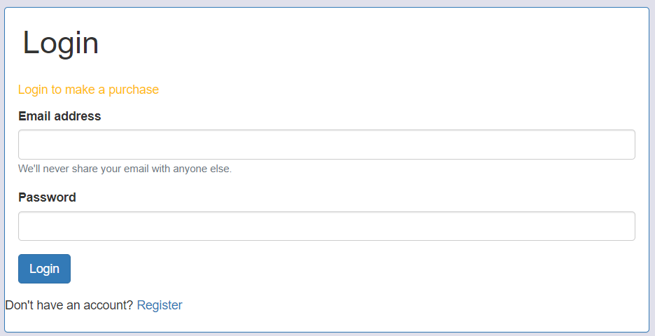

Panel-heading

Text-warning

Panel-body

Panel-footer

a. Create a Bootstrap primary panel with header and footer.

b. Inside the panel body, add text “Login to make a purchase” in a paragraph tag with class text-warning assigned to it.

c. Below the text content, create a login form with email and password fields using Bootstrap form classes form-group and form-control.

d. Add a button below the email and password field using Bootstrap button classes btn and btn-primary.

e. Add “Don't have an account? Register” in the panel footer using the class panel-footer.

4. Add the footer at the end of the page.



* **Signup page**

1. Create a header and add navigation links to signup (signup.html) and login page (login.html)



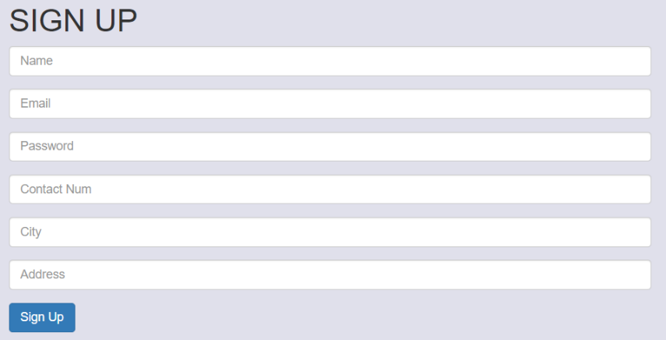2. Using Bootstrap form classes create a signup form like this:

3. Add a footer below the form.

When you’re done, the signup page should look like this:

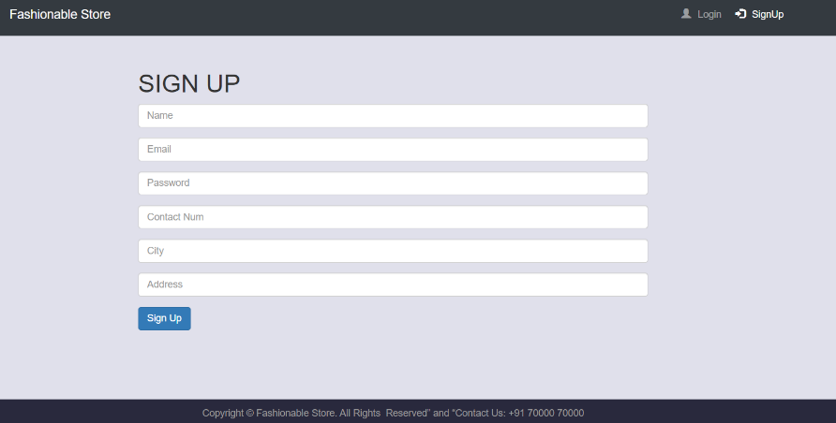

* **Products page**

Create post login products page. The post login web page is divided into three

sections:

1. Header with navigation links to cart, settings and logout.

2. Content

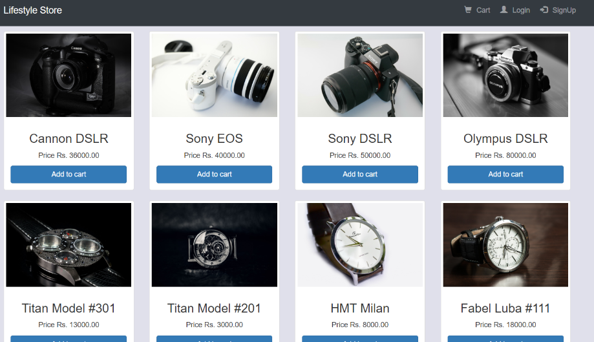 3. Footer.

1. Create an after login fixed header navigation bar using the Bootstrap navbar classes like this <div class="navbar navbar-inverse navbar-fixed-top">.



2. This is a collapsing navbar, include the navigation options to cart, settings and logout.

a. Link the cart option to cart.html

b. Link the settings option to setting.html

c. Link the logout option to logout.html

3. Create a div and assign class container to it.

4. Create a row adding cameras, assign class text-center to the row.

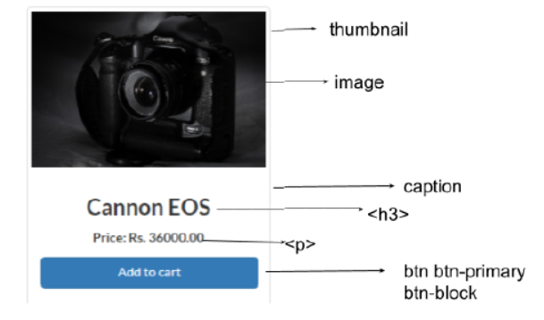 6.

 7. Add the footer at the end of the page.

* **Cart page**

The cart page is used to verify and confirm the item purchase of the items added to the cart. This is how the cart page should look like:

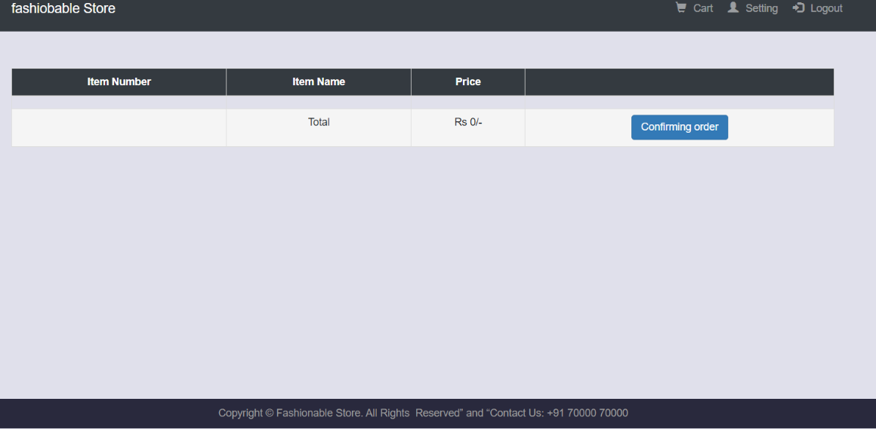1. Create an after login fixed header navigation bar.

2. Create a table with 4 columns and 3 rows. The table has “Item Number, Item Name, Price” as table headers. Add a link to the success.html page inside the 3rd row, 4th column and assign classes “btn btn-primary” to the <a> tag.

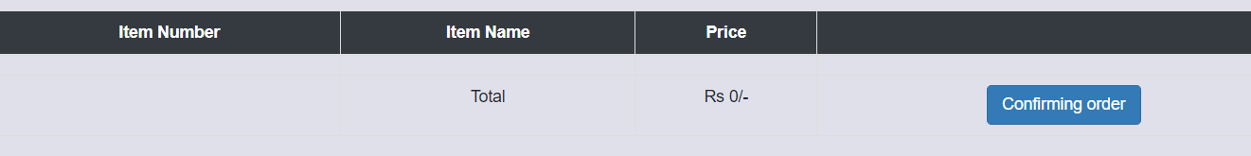

3. Add the footer at the end of the page.



* **Settings page**

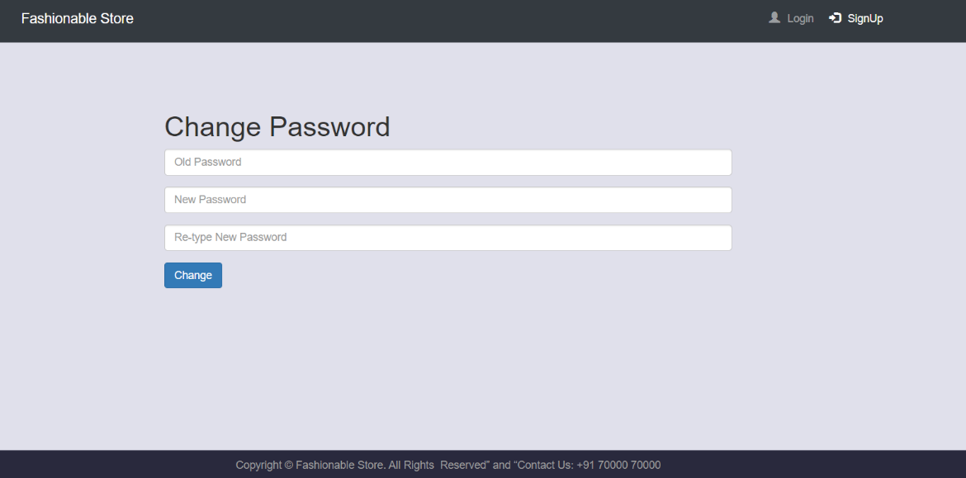The settings page is used to update a user’s password. This is how the settings page should look like:

* **Success page**

It should contain the message:

* Display success message: Your order is confirmed. Thank you for shopping with us. Click here to purchase any other item.
* Click here in the success message will be a link to products.php page.